CAUTION
AUTHORIZED PERSONNEL ONLY

NO EATING, DRINKING,
OR SMOKING PERMITTED IN LAB

TAMUG POLICE (24 HOURS) X 4545 EH&S Laboratory Safety Unit X 4055
FIRE/MEDICAL EMERGENCY 911 EH&S Radiation Safety Unit X 4055

Directions: Check box to left of Pictogram if hazard is present in your lab. If in large quantities, check box to right of pictogram.
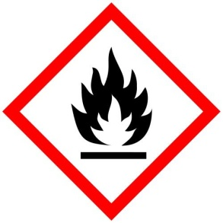 Large Quantities  Flammables Over 10 gallons |  |  Large Quantities  Compressed Gases Over 400 Liters |  | 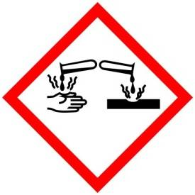 Large Quantities  Corrosive Over 10 gallons |  | 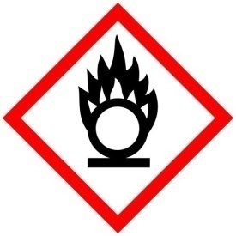 Large Quantities  Oxidizer Over 10 gallons
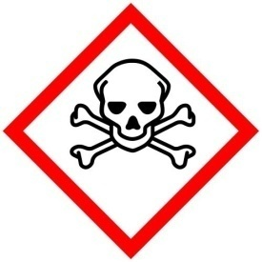  Acute Toxicity Large Quantities  Over 500 grams |  | 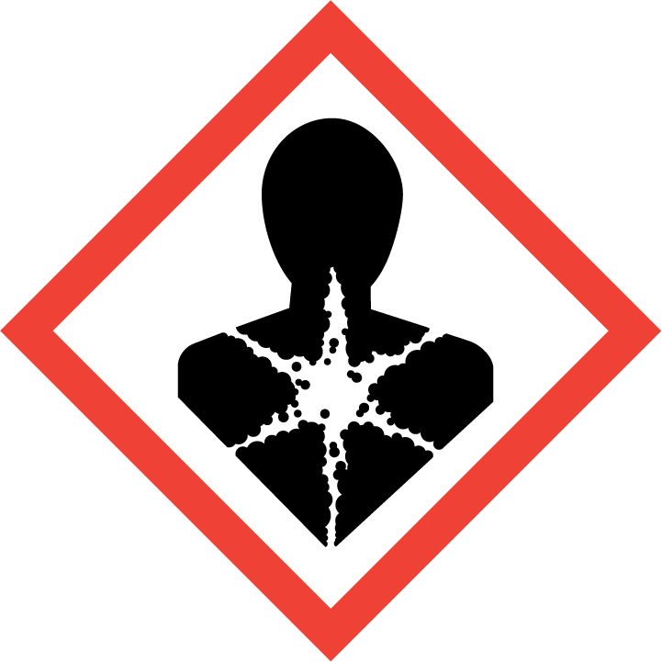  Carcinogen Large Quantities  Reproductive Hazard Over 500 grams |  | 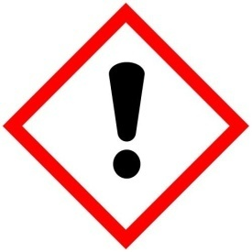  Irritant Large Quantities  Sensitizer Over 5 Kilograms |  | 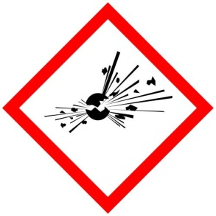  Explosive Large Quantities  Over 1 Kilograms
Visitors: Consult Laboratory Staff for required Personal Protective Equipment.

CONTACT | NAME |  | DEPARTMENT/OFFICE ROOM |  | OFFICE PHONE |  | CELLULAR PHONE
PI
Manager, EHS | Ms. Dee Ann Haney |  | EHS/SAGC Room 911 |  | 409.741.4055 |  | 409.771.0450
Courtesy: University of Rochester; https://www.safety.rochester.edu/labsafety/signage/labdoorsignage.html
UPDATED: 05/18/2023 Update sign when major changes occur.

